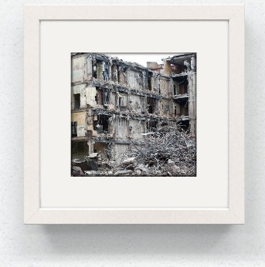
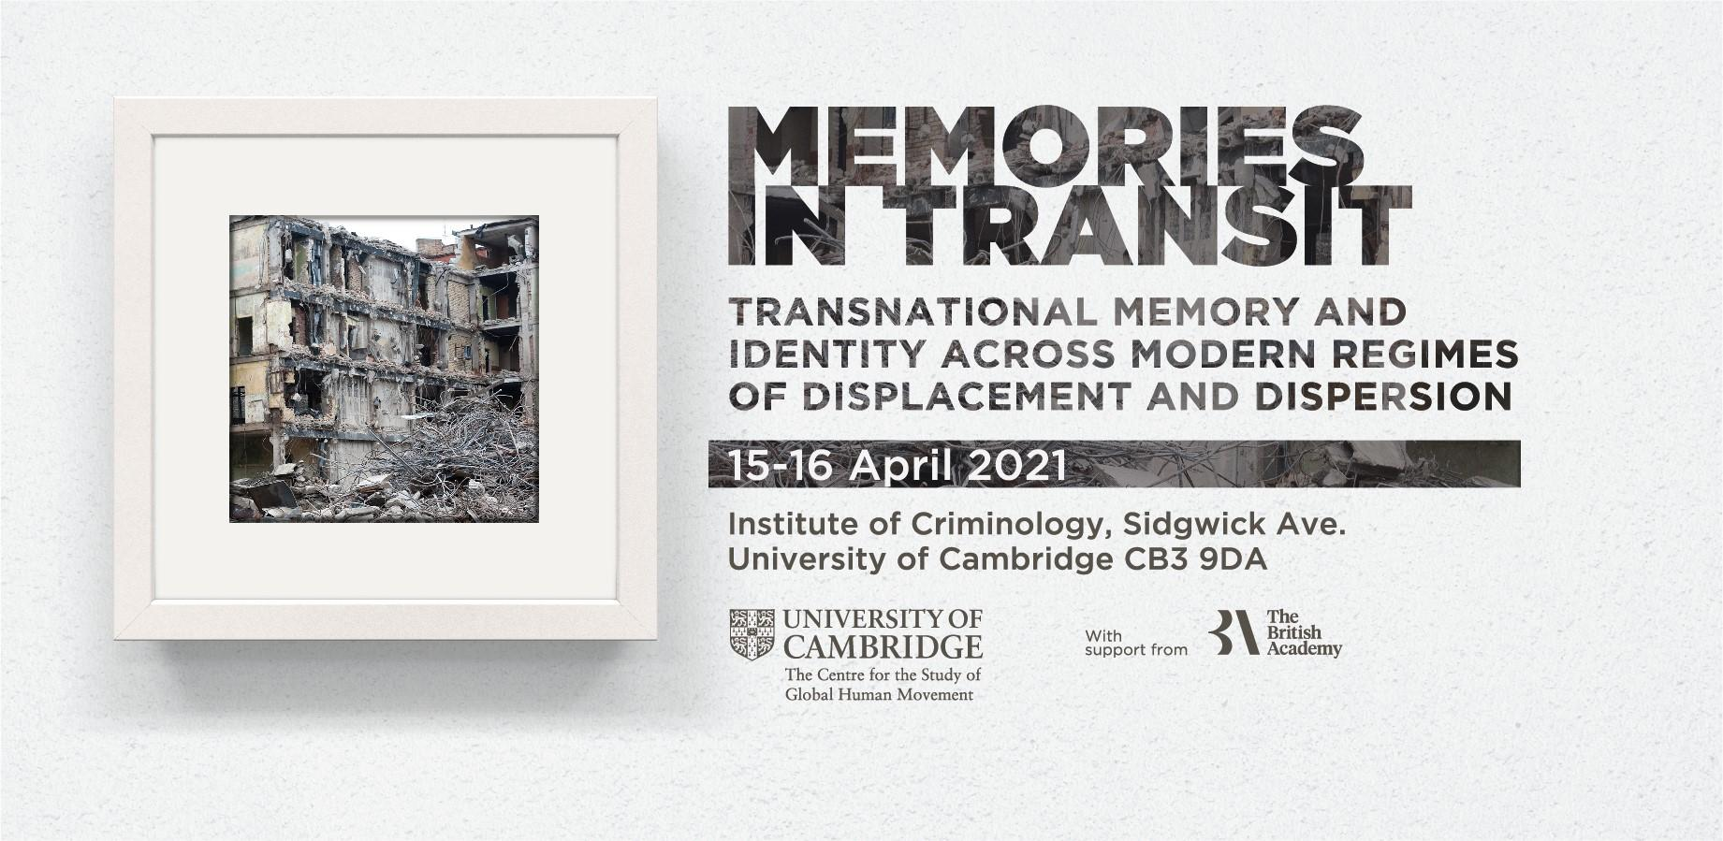

CONFERENCE PROGRAMME

Thursday 15 April
2.00 pm to 3.45 pm | Welcome address  Rin Ushiyama  Jessica A. Fernández de Lara Harada  Zeina Al Azmeh  Opening remarks  Jenny Mander  Keynote lecture: Memory in Liquid Time  Marianne Hirsch & Leo Spitzer
4.00 pm to 5.30 pm | Exile and narrative identity  Chair: Rin Ushiyama
Researching Syrian Memories of Academic and Student Displacement and Exile in Higher Education: Time, Memory, and Conflicted Tales of ‘home’
Jo-Anne Dillabough

From a Politics of Being Perceived to a Politics of Perceiving
Zeina Al Azmeh

Voices from the foreign land: Examining Gukurahundi discourses from displaced victims
Lungile Augustine Tshuma

5.45 pm to 7.15 pm | Literature as memory  Chair: Janani Ambikapathi
The Antinomy of Exile in Tendai Huchu's The Maestro, The Magistrate, and the Mathematician
Tanaka Chidora

Fragments of Utopia: Imaginary Archives in Dubravka Ugrešić’s Fiction
Vladislav Beronja

A Lost Homeland and a Continuous 'Nakba': Reading Palestinian Literary Narratives of Exile as a form of 'emotional knowledge'
Roba Al-Salibi

7.30 pm to 9.00 pm | Haunting memories of racial violence  Chair: Njoki Wamai  Integration and Racialization of Black Immigrants in the United States  Annie Zean Dunbar  I am Memory: Memory, Body, Territory. Lessons from elaborating historical memory amidst the Colombian armed conflict  Claudia Gonzalez  Building an archive: Valeria Luiselli’s "Lost children archive"  Delia Grosu

Friday 16 April
9.00 am to 10.45 am | Transnational memories of the Second World War  Chair: Rachel Leow
Places of reconciliation: negotiating transnational and transcultural memory in military mortuary spaces
Alison Starr

The transnational cultural politics of historical denial: Japanese nationalism and the new Japanese-American right
Rin Ushiyama

The Diaspora of the Chinese War Dead: Transnational Memorialisation of the Fallen Soldiers in the Second World War
Zhenru Lin

Writing in reverse: Mexican Japanese memories of WWII as resistance against racism
Jessica A. Fernández de Lara Harada

11.00 am to 12.45 pm | Memory activism  Chair: Katherine A. Mato  Commoning the "cracks": Memory activism in curatorial practices  Dimitra Gkitsa  Moving Pasts: Vernacular dance as a vehicle for embodied memories among the female Bangladeshi diaspora in Tower Hamlets, London  Julia Giese  The Soundtrack of Exile. Affective Archives of Karolina Grzywnowicz Justyna Balisz-Schmelz  Walking as Transcultural Memory Activism  Michal Huss
12.45 pm to 1:30 pm | Lunch
1.30 pm to 3.00 pm | Transitional justice  Chair: Zeina Al Azmeh  Answering Memories: A case study of memorial intervention in mediating for post-war justice in Sri Lanka  Dalia N  Returning memory: Using memorialisation to localise remembrance and repair  Quito Tsui  Denial, hope and transnational affective relations  Pauline Stoltz
3.15pm to 5.00 pm | Memories of migration, nostalgia and community  Chair: Jessica A. Fernández de Lara Harada  Beyond the border of History. Some reflections on memory and intersubjectivity  Gabriele Proglio  The “Unaccustomed Earth”: Memory, Migration and the Quotidian in the Literature of Indian Partition  Anuparna Mukherjee  Arabs, Israel and the cosmopolitan nostalgia of Jewish post-colonial migrants in Britain and France  Liran Morav  “No Humans Involved”: On the Im/possibilities of Black Mourning from the Ship to the Black Atlantic  Ola Osman
5.15 pm to 6.30pm | Mediating memory  Chair: Jenny Mander  Witnessing Eva Stories: Media Witnessing and Self-inscription in The Social Media Experience  Lital Henig  "We want a museum like in Solingen!". Transnational Forms of Remembering and the Sivas Massacre in Turkey  Fabio Salomoni  Migrant Narratives in the Museum – Stories that Stick with Us  Yvonne Zivkovic

6.30pm to 7.00pm Final remarks and future initiatives
Zeina Al Azmeh
Jessica A. Fernández de Lara Harada
Rin Ushiyama

