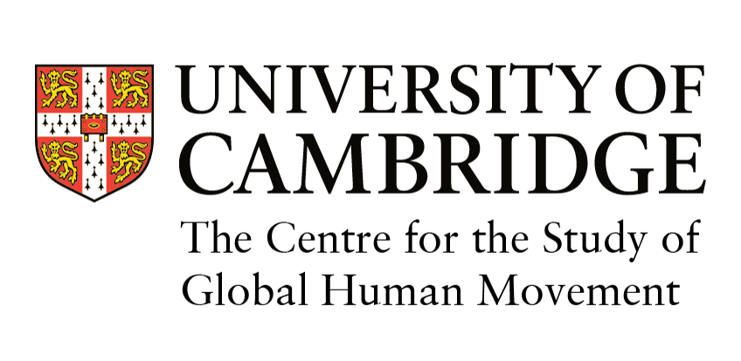

Partnership, Impact and Collaboration (PIC) Grants

The Centre for the Study of Global Human Movement has been founded to promote a dynamic, coherent transdisciplinary programme of migration research at the University. In order to stimulate the development of new migration research projects, it wishes (a) to prioritise the development of collaborative partnerships and (b) to ensure that the impact of any research activity or project or any innovative tool is established at the outset. With this in mind, the Centre has decided to offer a number of small Partnership, Impact and Collaboration grants.

Partnership, Impact and Collaboration (PIC) Grants of up to £2,500 per award per year will be awarded to members of the Centre for the Study of Global Human Movement who are based in the University of Cambridge. These grants can be used to support the research activities of members of the Centre whether these involve establishing a core infrastructure and/or whether such activities require funding to facilitate the development of external research grant applications. We encourage interdisciplinary proposals. The grants can cover, for example:
  - Grant-writing workshops and associated travel and hospitality costs to develop a research bid;
  - Research seminar series with invited potential research partners;
  - Policy workshops/symposia at Cambridge to develop key research agendas and ensure impact;
  - Invitations to individual academics in the UK and abroad to come to Cambridge in order to scope or develop a research bid;
  - Travel to a research workshop to establish international partners in a research bid; and,
  - Conferences for dissemination and impact.

Eligibility Full members (established research and teaching staff within the University of Cambridge) of the Centre for the Study of Global Human Movement are eligible to apply. Postgraduate members of the Centre (within the University of Cambridge) will need to apply jointly with a full member. Applicants are only eligible to apply for a grant once in any Centre year (April – Mar).

Eligible researchers working on migration and migration-related issues can apply to become members of the Centre by either emailing Di Kennedy (dk575@cam.ac.uk) with the following details: name, title, department, description of their migration-related research interest, and titles of relevant publications or via the following form https://www.humanmovement.cam.ac.uk/membership-form .

Deadlines Applications are accepted on a rolling basis.
The review committee will usually respond within one month of submission.

Submission The application should consist of: A. PIC Application Summary (Form 1) and B. PIC Grant Applications Budget (Form 2). If the application involves a graduate/undergraduate student, a letter of support from a supervisor, course director or Director of Studies is required.

Each application needs to identify full detailed costs of the activities. Ideally applications will have identified other funds to help support the activity.

If the application refers to more than one activity within a strand of work, then the applicant only needs to submit detailed costings for the first activity of the strand (it would be helpful though to provide a rough estimated costs for the other activities). Additional applications can be submitted later with the detailed costing for these subsequent activities. Please note that the total budget for any one year cannot exceed £2,500.

Applicants are encouraged to consult Dr. Tugba Basaran, Senior Research Fellow, (tb317@cam.ac.uk) for questions on the suitability of their proposal. Applications should be submitted via the attached application form to Di Kennedy, Research Administrator (dk575@cam.ac.uk).

Applications will be considered by a panel and, if necessary, advice will be sought from members of the Centre’s steering group.

Reporting As a condition of award, within two weeks after completion of activity each awardee must write a short report (max. two sides of A4) on the activities funded by the grant and the impacts achieved. The report should be sent to dk575@cam.ac.uk. A summary of the report may be published on the Centre’s website. The Centre would appreciate any other related material (such as working papers, or research notes, photographs of the event and a list of participants) associated with such research activity.

Any film of a research event would need the participants to sign a consent form which could be submitted for dissemination through the Centre website (the form can be obtained from Di Kennedy and will need to be returned to her when completed by participants).

Expenses A list of preferred suppliers will be provided and must be utilised. Receipts for agreed expenses are needed for all costs and will normally be reimbursed after the event. Expense claims should be submitted to dk575@cam.ac.uk.

August 2019

Form 1: PIC Grant Application - Summary

Application Title:
Application Date:
Coordinator Name:
Organiser Names:: | Please list all members of the organising group, starting with the coordinator.
 | Full name | Affiliation (Faculty/ College) | E-mail address
Total Grant Requested: |  |  | £
Research  Activities Planned: | Please list all activities (workshops seminar, conference) separately
 | Activity (type) | Proposed Date of Activity | Grant Requested
 |  |  | £
 |  |  | £
 |  |  | £
 |  |  | £
 |  |  | £

Please provide an application summary. Be brief and limit it to a maximum of two A4 sides, single spaced.
- Background and aim
- Activities and details of the work to be undertaken
- Planned research output
- Planned impact, i.e. how the application contributes to partnership, collaboration and/or impact
- Collaborative centre research, i.e. how the proposed work contributes to the development of interdisciplinary collaborative research at the Centre the Study of Global Human Movement and at the University of Cambridge
- Anticipated follow-on activities, including the ways in which the proposed work supports the submission of further migration research grant applications? Please include information of potential funders, date of grant application and submission targets.

Date and Signature:

Form 2: PIC Grant Application - Budget
Title of Activity:
Date of Activity:
PIC Grant Request (£):
a. Other Funding (£) | Please list all other income (grants, fees collected) related to this activity
 | 1.
 | 2.
b. Expenses (£) | Please list all expenses. Please note that we cover the equivalent of second-class bus, train and airfare (not taxis). Please note that we normally cover basic college or three star accommodation.
 |  | No. of people | Cost per person | Total Cost
 | Travel Costs
 | Local (up to £70)
 | UK (up to £200)
 | Europe (up to £300)
 | World (up to £500)
 | Accommodation
 | Catering
 | Breakfast
 | Lunch
 | Dinner
 | Tea & Coffee
 | Other Costs
 | Room Hire
 | Equipment Hire
 | Staff Costs
 | Other Costs (i.e. poster, leaflet)
 | Contingency
 | Total Expenses

Notes: | Please provide additional information about the above-listed costs.

